
All About My New Teacher Miss Hall
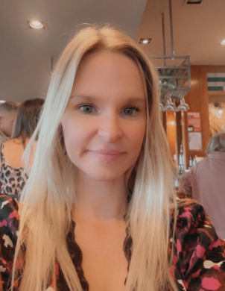
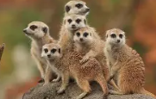
Class Name: Meerkats

Fun facts about me:
- I love dogs and have 5!
- I enjoy going to the gym and lifting weights.

- When I’m not in school I love going out for coffee with my friends.
Things I do in school:

I am EYFS and Key Stage One leader. This means that I make sure children in these year groups are trying their best. In school I also lead Phonics and enjoy watching children learn to read!

